**Introduction to Power BI**

Microsoft Power BI is a powerful tool designed by Microsoft for creating interactive data visualizations with a focus on business intelligence. It combines software services, applications, and connectors to transform data from multiple sources into dynamic visual reports. Data can be imported from databases, web pages, PDFs, or structured formats like spreadsheets, CSV, JSON, XLSX, and SharePoint.

* **CSV Files**: Commonly used for compatibility with various programs, CSV (Comma Separated Values) files are plain text files that store data in a simple, organized manner. These files can be opened in text editors, spreadsheet tools like Excel, or other specialized software.
* **JSON Files**: JSON (JavaScript Object Notation) files are lightweight, text-based formats for exchanging data between web applications and servers. They are human-readable and can be modified using basic text editors.
* **XLSX Files**: XLSX files are used in Microsoft Excel to manage data using tables. They allow for storing, analyzing, and performing calculations using formulas within the spreadsheet.

**Steps to Install and Use Power BI:**

1. Search for "MS Power BI" online and download the desktop application from the official Microsoft website.
2. Open the Power BI desktop application and select "Blank Report" to start a new project.
3. Import a dataset from your device by choosing the desired file type. You’ll have the following options:
   * **Load**: Directly imports the data as is.
   * **Transform**: Opens the Power Query Editor for data preprocessing.
   * **Cancel**: Stops the import process.

For example, in the Power Query Editor, you can clean your dataset by removing unnecessary columns. Once the required changes are made, click on "Close and Apply" to save your edits and proceed with analysis.

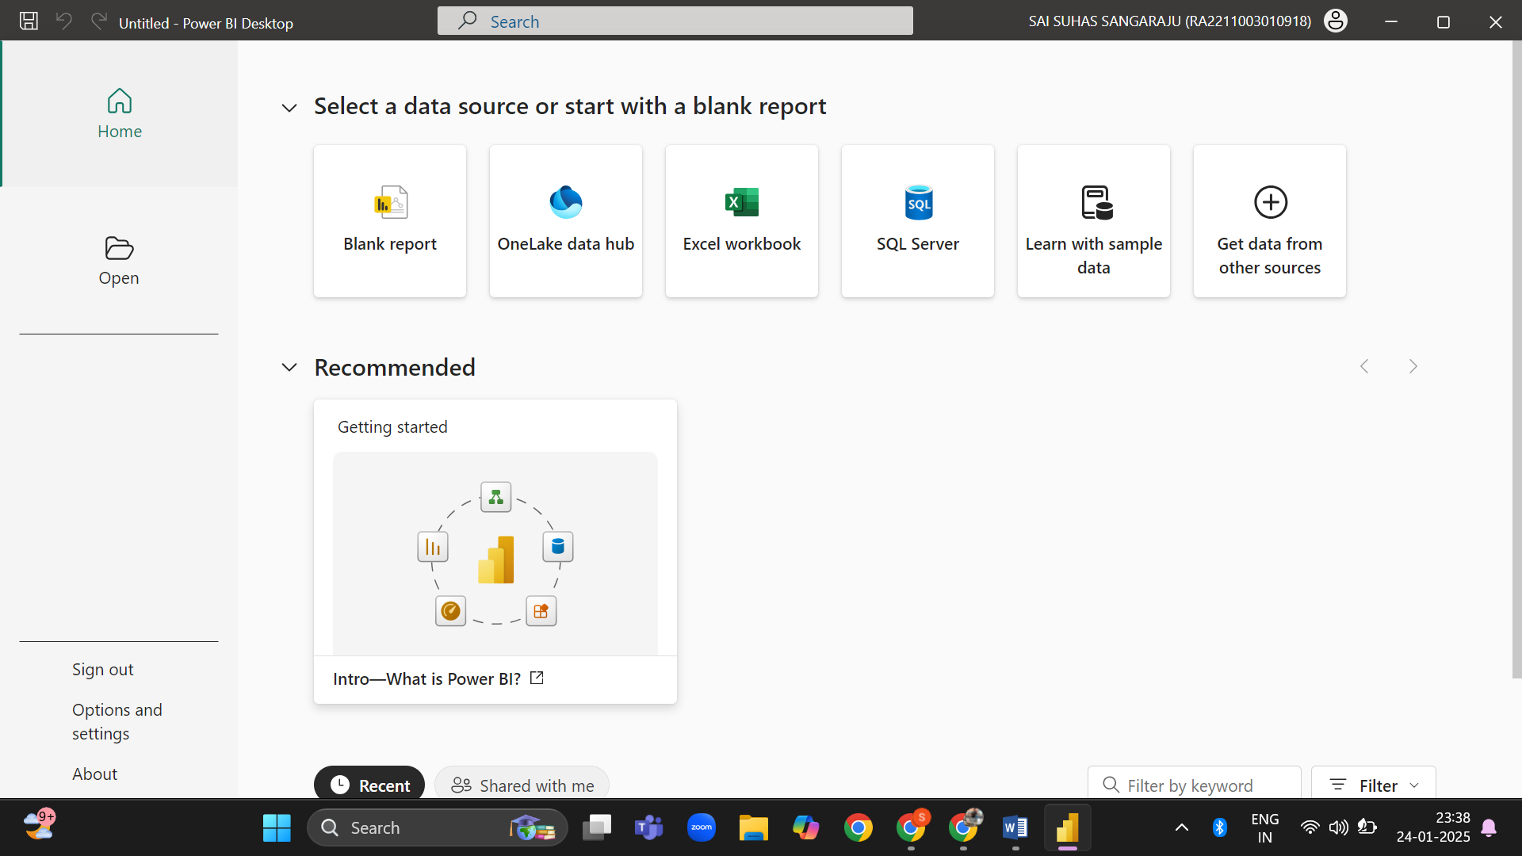

To upload a dataset in Power BI, click on "Import Data from Excel." Select the file you want to upload, and you’ll see three options:

* **Load**: This option imports the data directly without changes.
* **Transform**: Use this to preprocess and clean your data before importing.
* **Cancel**: Deselects the file and stops the import process.

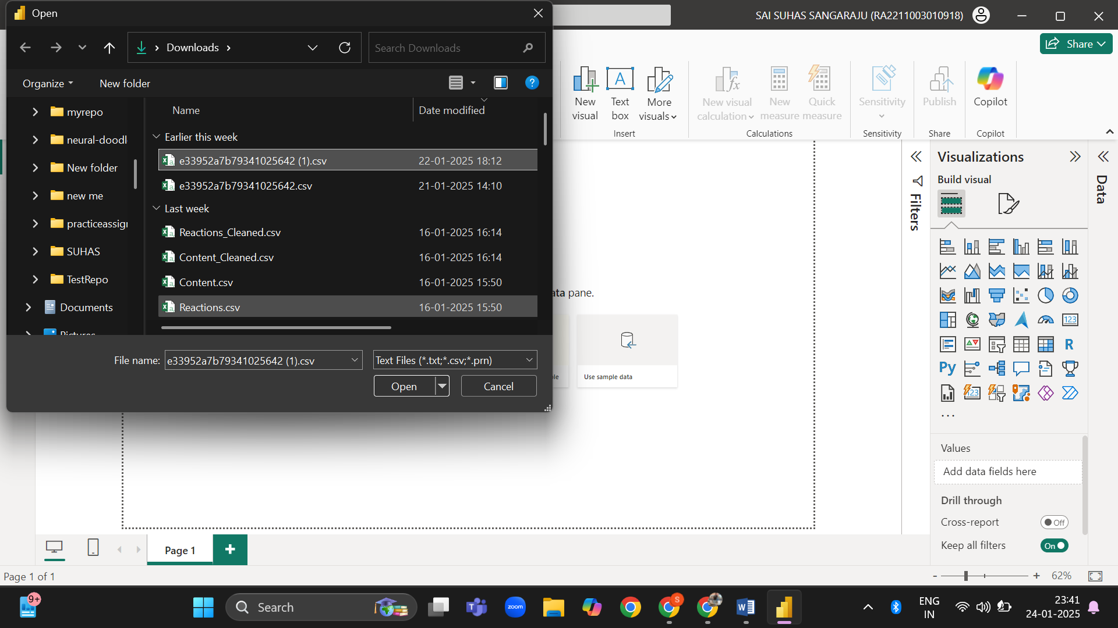

For demonstration purposes, we will proceed without preprocessing and directly click on the "Transform Data" icon on the taskbar. This action opens the Power Query Editor, where files can be edited as needed.

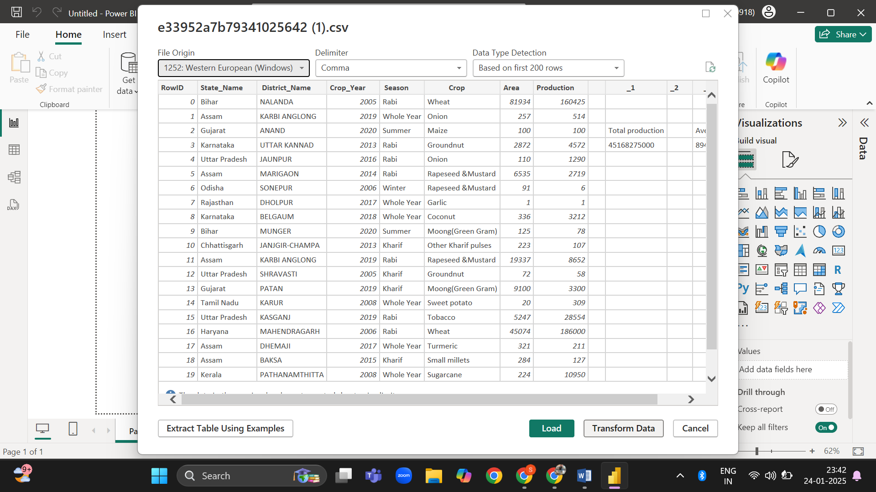

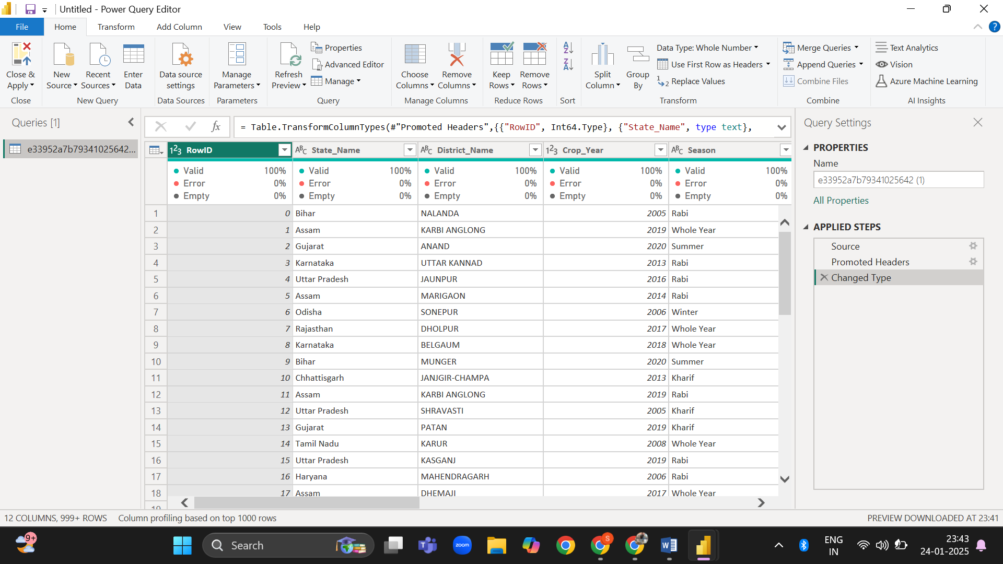

For instance, let’s remove the "Production" column. Select the column, right-click on it, and choose "Remove." After removal, you’ll notice a new step labeled "Removed Columns" added in the **Applied Steps** section.

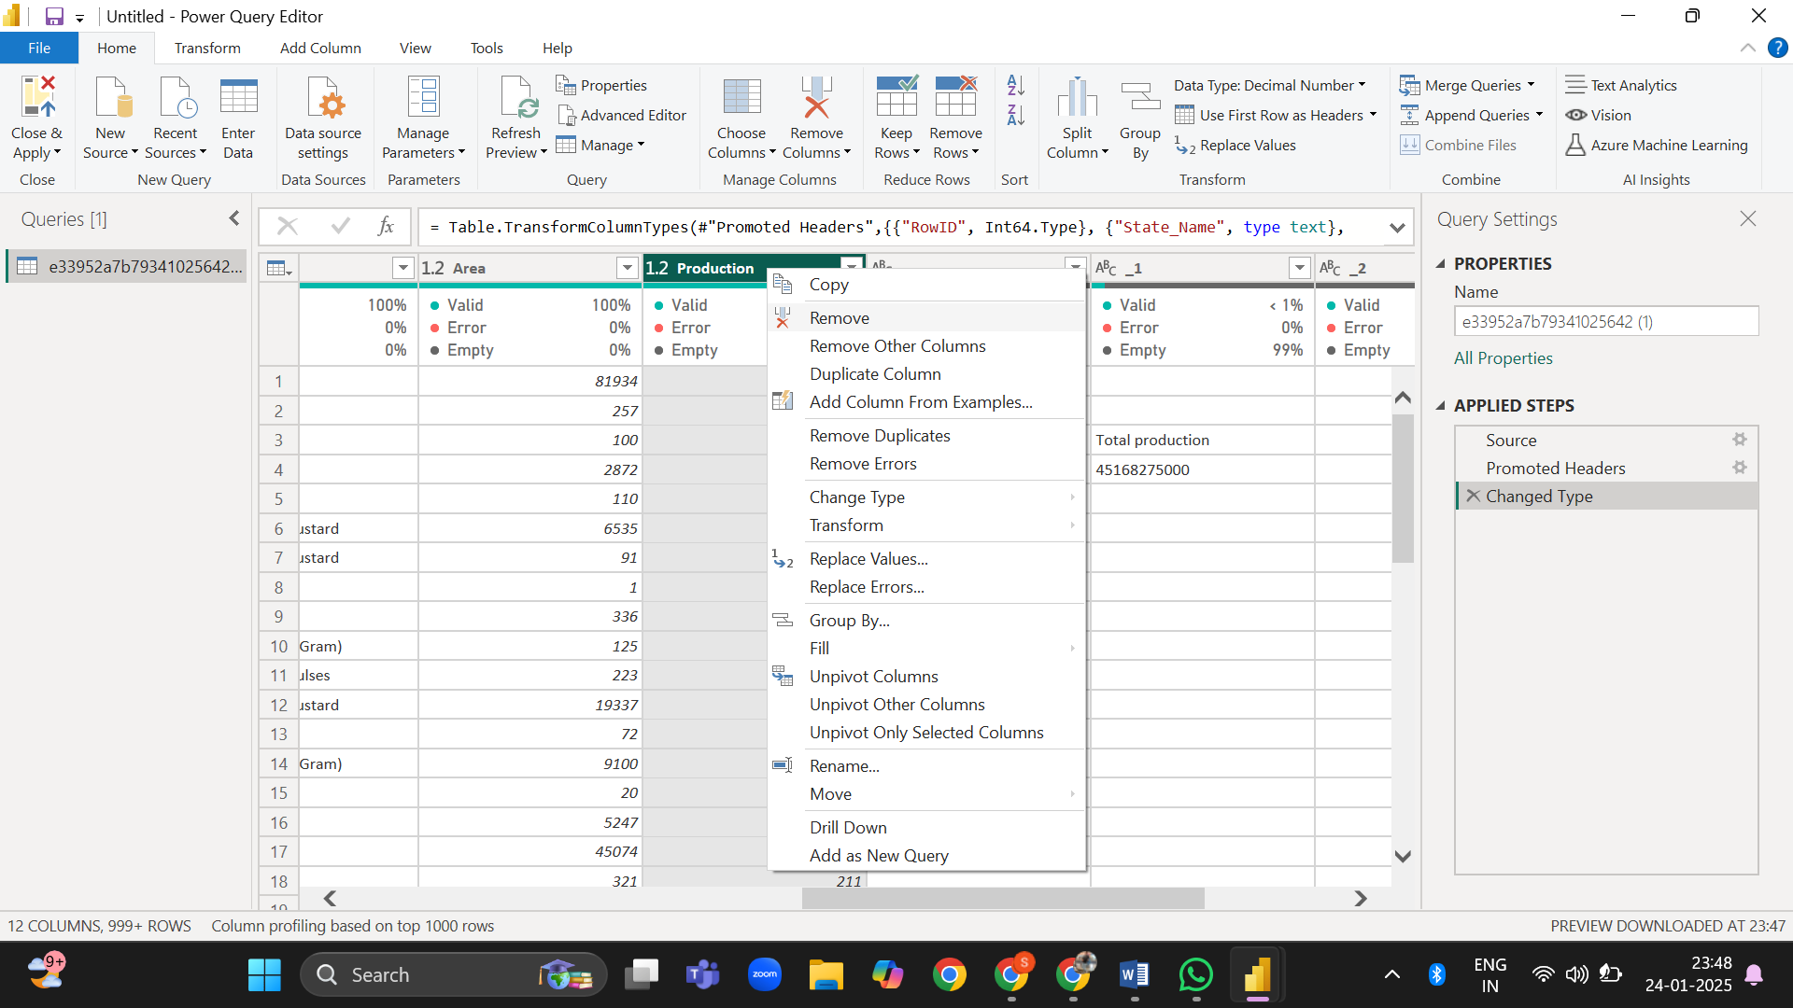

Finally, click on "Close and Apply" to save the changes and return to the main interface with the modified dataset.

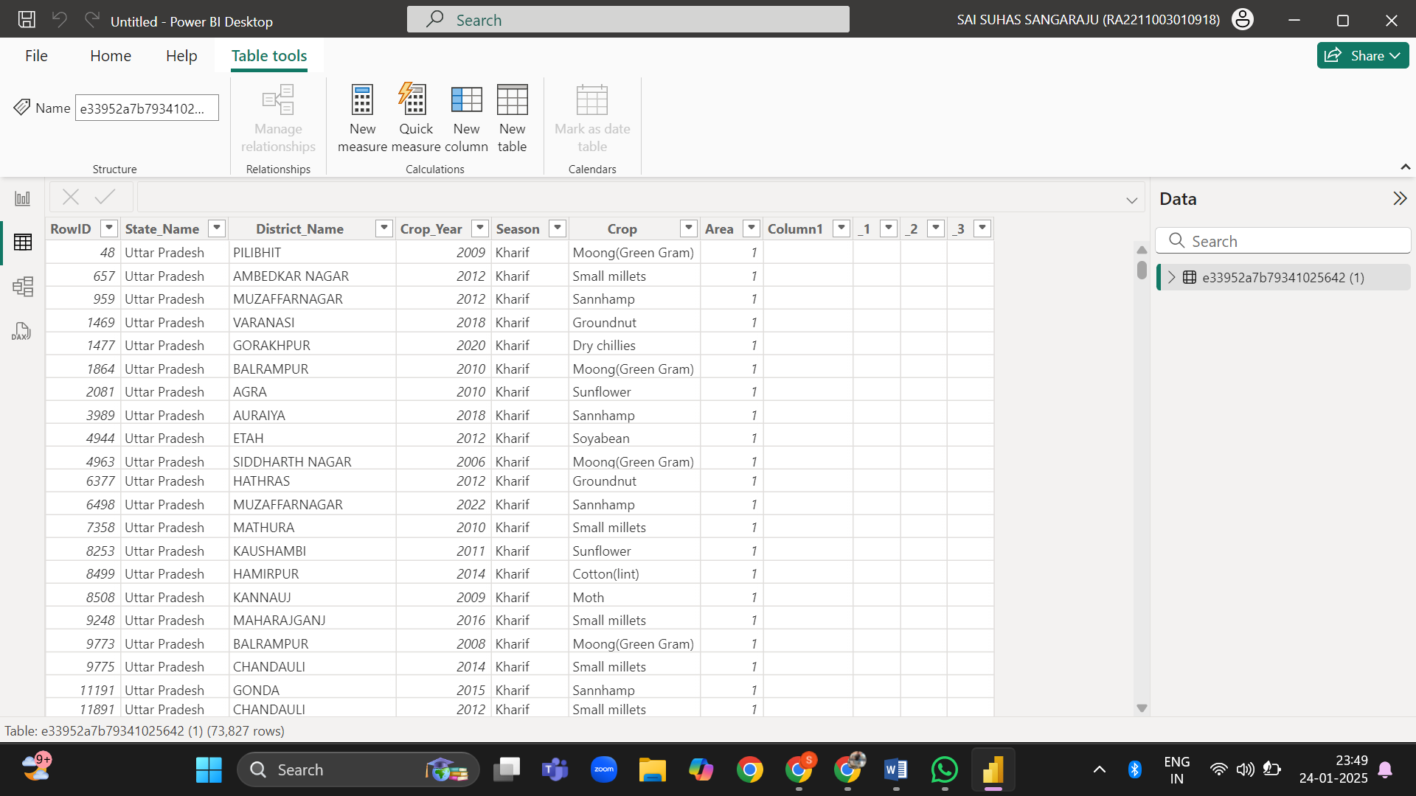

The above is the modified dataset without Production Column

After completing the data transformation process, Power BI enables you to design interactive dashboards and reports tailored to your needs. Its robust visualization tools make it easy to identify patterns, analyze trends, and derive actionable insights from your data. By leveraging Power BI's capabilities, you can make informed decisions and present complex information in a visually engaging and simplified manner.

Sai Suhas Sangaraju

[ss0174@srmist.edu.in](mailto:ss0174@srmist.edu.in)

+91 9052359593